The Solution

## User Manual

## 

## 

### **Table of Contents**

### Assembly and Introduction ………………………………………………………….…………………3

Instructions for Use …………………………….……………………….……………………………….5

Maintenance …………………………………………………………………………………………………6

Warranty Information ……………………………………….………………...………...………………..6

Service Center …………………………………………………………………………………………………7

### **Introduction**

We at Case-Closed Industries have engineered a toiletry case optimized for daily use and efficiency. Our design is most useful when traveling lightly and compactly.

**Assembly**

Bottom Section

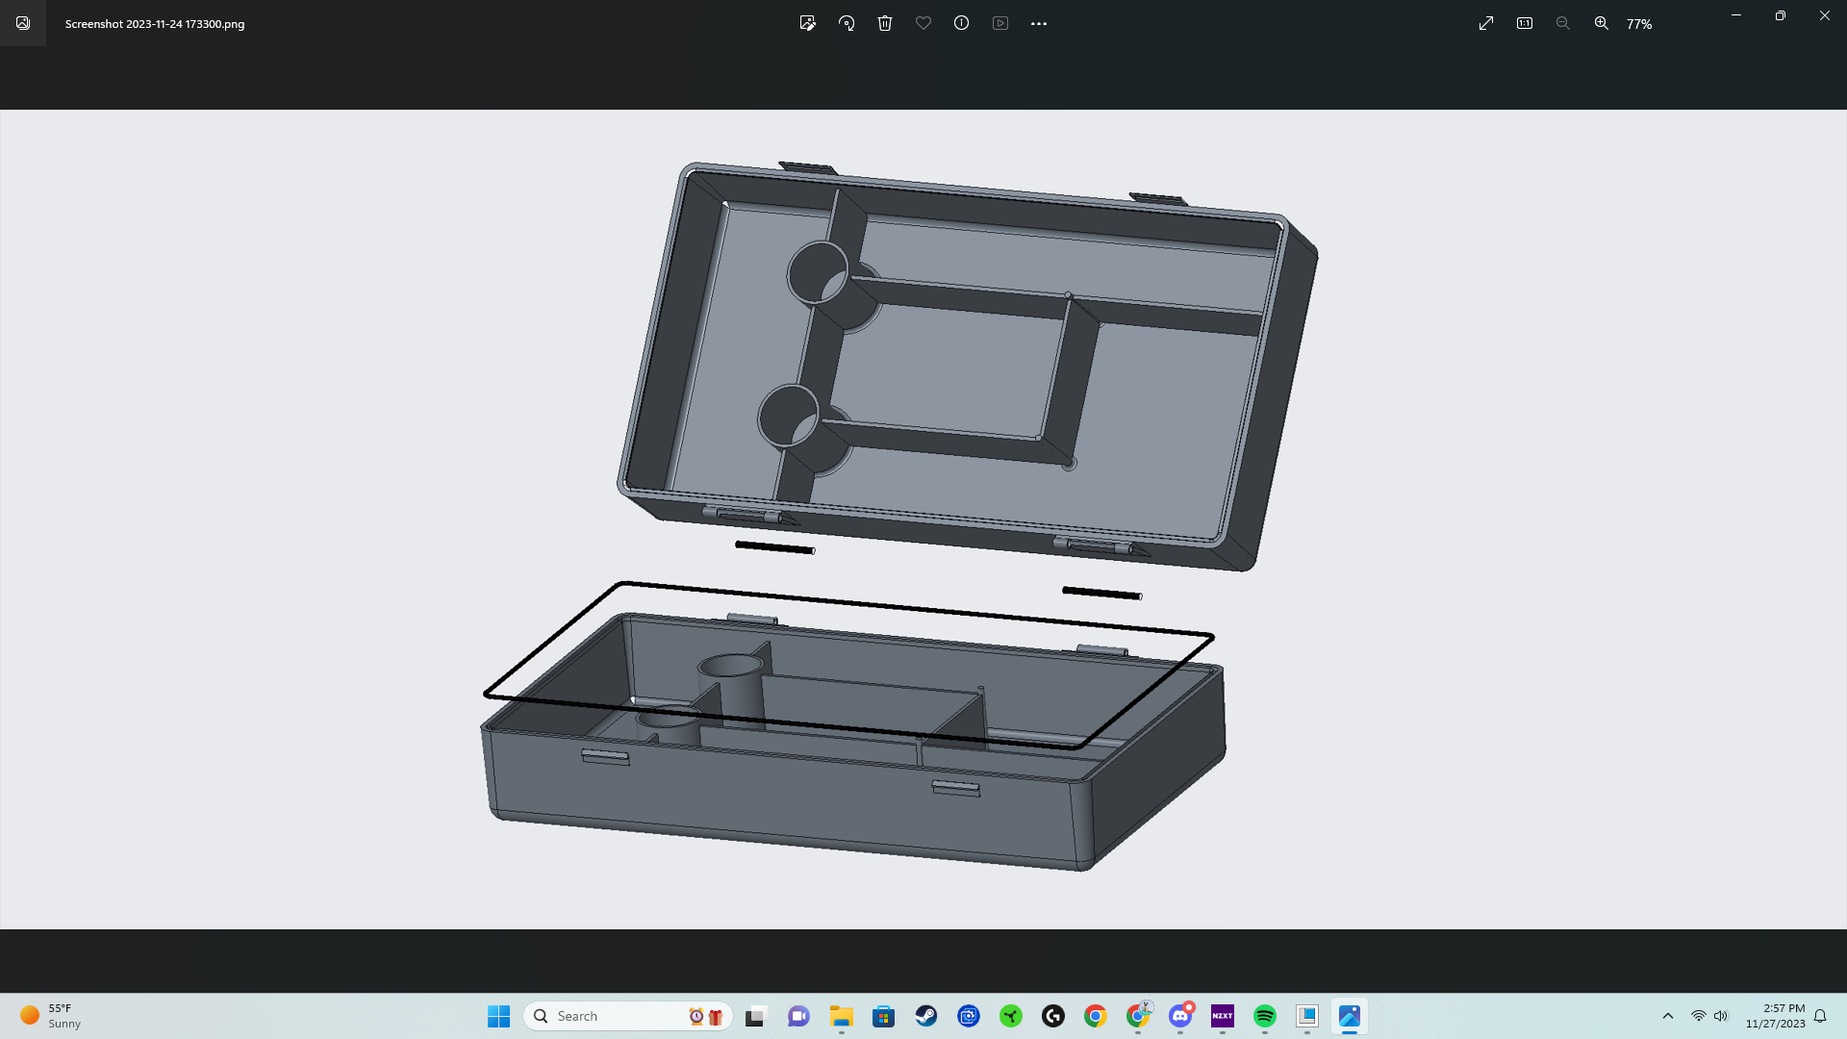

Top Section

Hinge Pins

O-Ring

Top Hinge

Bottom Hinge

***Figure 1***

*The Solution* is made up of five components, as seen in Figure 1:

* Injection-molded Top Section
* Injection-molded Bottom Section
* Stainless Steel Hinge Pins (x2)
* Rubber O-Ring

To assemble *The Solution*, line up the top and bottom hinges. The bottom hinge knuckle will fit snugly inside the top hinge knuckle. Then line up each hinge pin with the hinge knuckle assembly and insert the pins until they are flush with the hinge knuckles. Finally, insert the O-Ring into the O-Ring groove, located around the opening edge of the Bottom Section. The assembled product should appear similar to Figure 2.

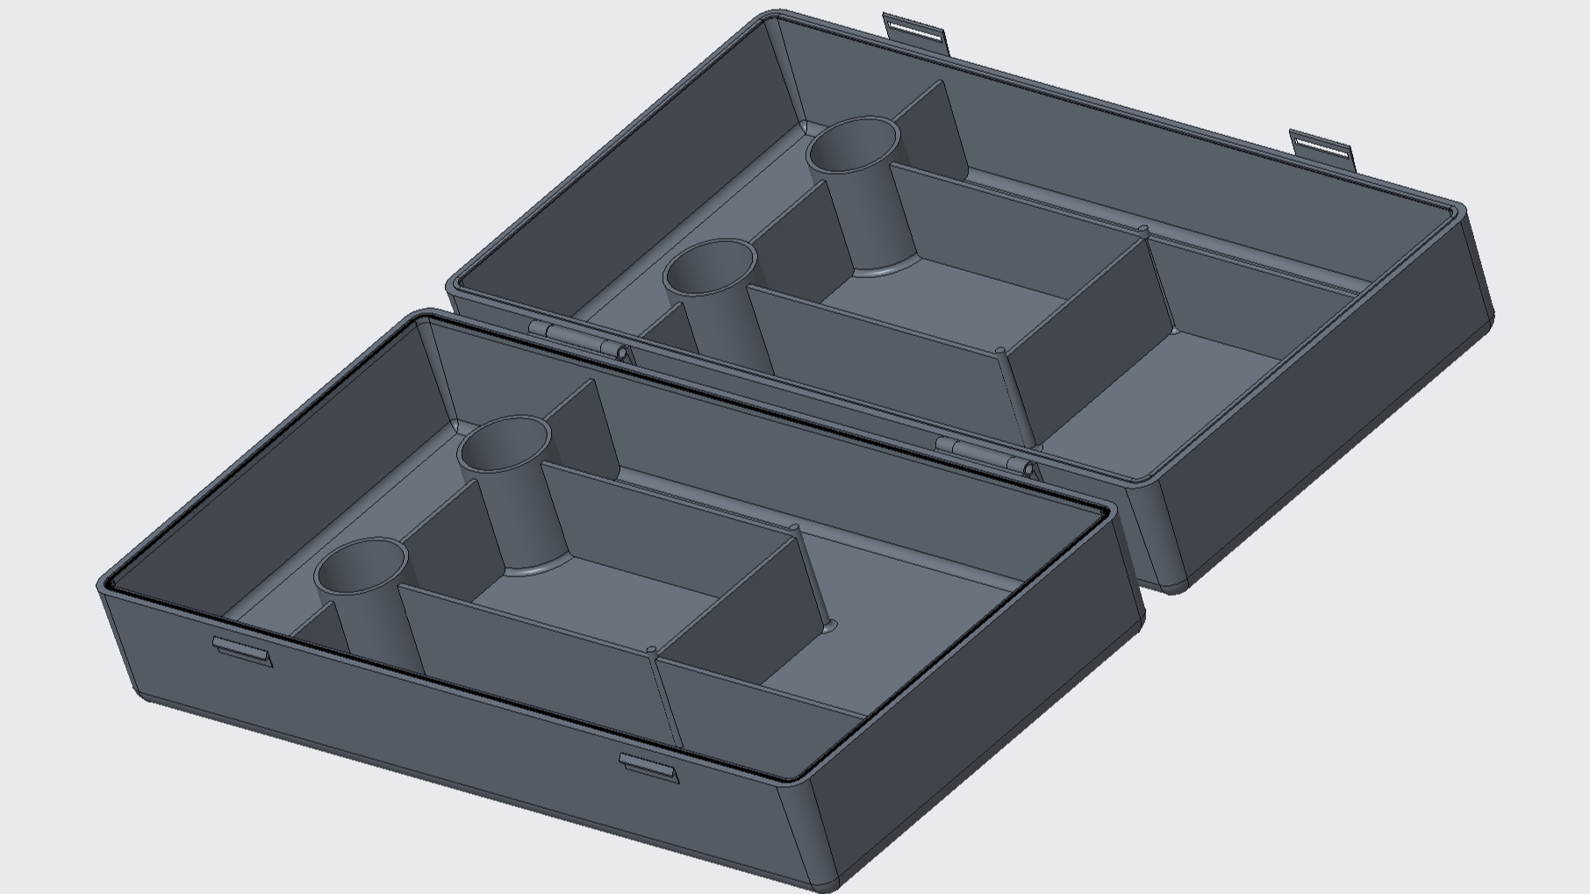

***Figure 2***

### **Instructions for Use**

Upon initial reception, it is important to verify *The Solution* has been delivered in good condition. Inspect the case for defects. Upon assembly, ensure the hinges move freely, the O-Ring is securely seated, and the front clips snap firmly into place when closing the case. We recommend a post-inspection initial wash of the case as well.

Personal hygiene items can be placed in any of the four main compartments. When opened fully, the number of compartments doubles to eight, making it a breeze to organize personal items in a manner protected from unsanitary surfaces. Additionally, when opened fully, personal hygiene items similar in form-factor to toothbrushes and razors can be placed upright in any of the four smaller cylindrical compartments, as seen in Figure 3.

***WARNING | An overfilled case will not close properly | WARNING***

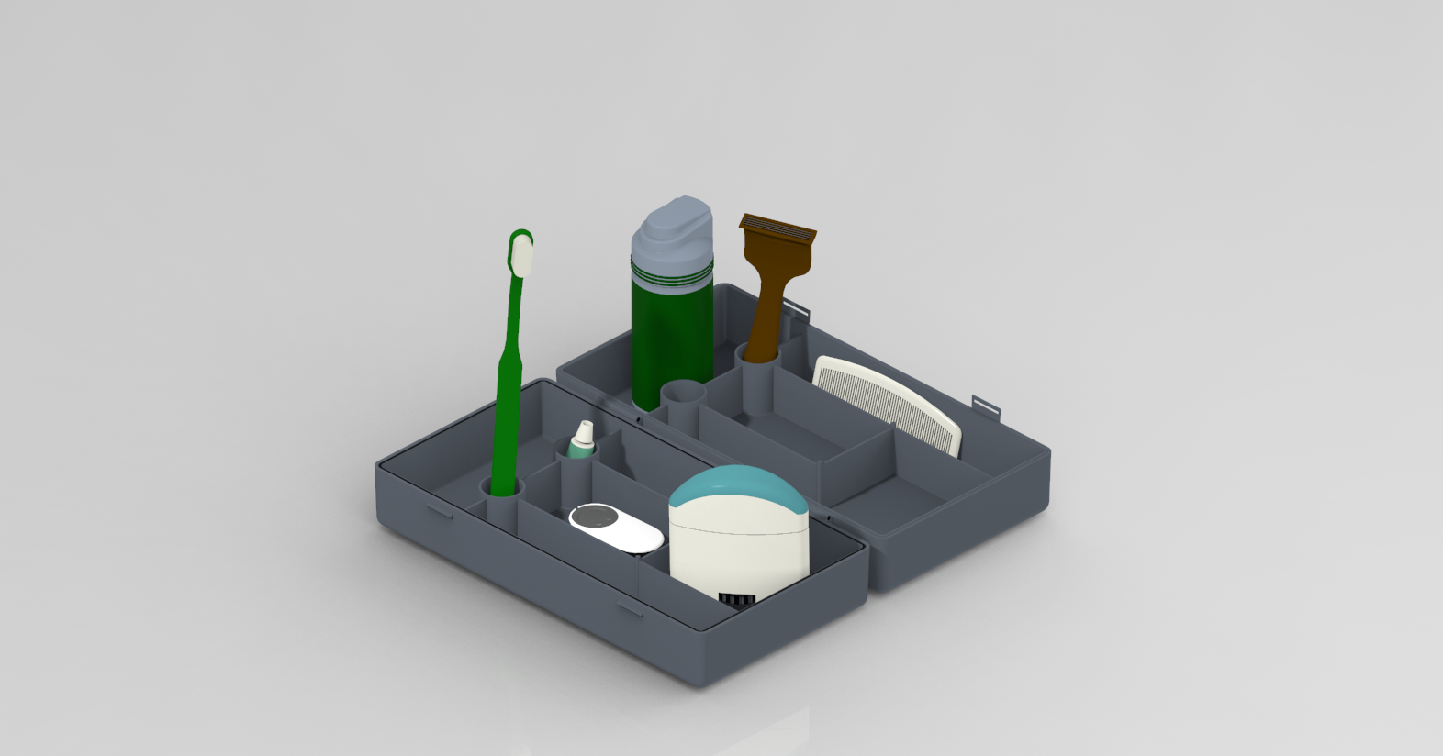

***Figure 3***

### **Maintenance**

*The Solution* should be cleaned regularly to prevent the formation of mold and mildew. The case can be cleaned either by hand washing with mild dish soap or by placing the fully-open case on the top rack of a dishwasher. (For ease of cleaning, the case is dishwasher safe). When washing, ensure the O-Ring has been removed and washed separately. Air dry the case and O-Ring after washing.

We recommend washing and drying the case after each use to minimize the potential for mold and mildew to build up.

### **Warranty Information**

Case-Closed Industries’ #1 priority is the satisfaction of our customers. Our warranty centers on user-friendliness and quality customer service. If the product is defective on delivery or breaks unexpectedly over the course of reasonable use, we encourage the submission of a warranty claim. The warranty claim filing process can be initiated by emailing our head of customer service, who will provide a digital form. Physical forms can be obtained at our Service Center.

*The Solution* comes standard with a six-month warranty. Case-Closed Industries also offers a lifetime warranty at half the price of the original product, purchasable at any time up to six months after the initial sale date.

Upon filing any warranty claim, Case-Closed Industries will review the claim and decide on a case-by-case basis if the product is eligible for refund or replacement.

### **Service Center**

Case-Closed Industries’ main service center is located in UNC Charlotte’s Hawthorn Hall at 9201 University City Blvd. Hawthorn Hall can be called directly at (704) 687 - 1756.

Case-Closed Industries can also be contacted through any of the following individuals.

|  |  |
| --- | --- |
| **Lucas Brockenbrough**  Spokesperson / Customer Service  [lbrocken@uncc.edu](mailto:lbrocken@uncc.edu) | **Isaiah Bosse**  Marketing  [ibosse@uncc.edu](mailto:ibosse@uncc.edu) |
| **Bryan Willis**  Lead CAD Designer  [bwill203@uncc.edu](mailto:bwill203@charlotte.edu) | **Aidan Stokes**  Lead Web Designer  [astokes8@uncc.edu](mailto:astoke@uncc.edu) |